This guide serves to show you, using illustrative examples, how to correctly map the features you are most likely to encounter. The quality of your tracing and tagging determines the quality of the map, so please review this guide carefully.

* This guide covers the use of the ID Editor (the platform used in the MapGive online tutorial). More advanced users may want to migrate to the JOSM editor at some point for improved editing efficiency (https://wiki.openstreetmap.org/wiki/JOSM).
* Basic panning and editing functionality is similar to other GIS software.
* It is important to become familiar with the shortcuts associated with some of the more heavily used editing tools to expedite the process.
* In ID Editor, shortcuts are accessed by first clicking on the feature (which will be either a line or a point). This brings up several options to edit the feature. Available shortcuts are specified below each editing option on the editing wheel. **\*\*Please refer to page 3 for a full list of shortcuts**

**Main target features**: (check the HOT “Instructions” tab for project specific features)

Some of the main target features to be edited in this area of interest include:

* Roads (highways, both paved and unpaved surfaces)
* Bridges
* Buildings
* Manmade structures (towers, high walls etc.)
* Streams

**Feature Tagging:**

In addition to tracing the main target features, it is important to tag each feature while editing which assures they are readily identified within OSM. Feature tagging is done through a table on the left side of your screen. The following table provides guidance on how to tag common features you may encounter.

Feature Tagging

|  |  |  |
| --- | --- | --- |
| **Type** | **Key** | **Value** |
| **Regular building** | **Building** | **Yes** |
| **Main road/highway** | **Highway** | **Primary** |
| **Secondary road/highway** | **Highway** | **Secondary** |
| **Tertiary road/highway** | **Highway** | **Tertiary** |
| **Unpaved local road** | **Highway** | **Unclassified** |
| **Unpaved surface** | **Surface** | **Unpaved** |
| **Industrial park** | **Land use** | **Industrial** |
| **Residential area** | **Land use** | **Residential** |
| **Farmland** | **Land use** | **Farmland** |
| **Streams** | **Waterway** | **Streams** |

**Set-up:**

Remember in the HOT tasker to click the checkbox for the NextView license agreement. This allows you to view the newest imagery.

The imagery may appear dim in your browser. You can adjust the brightness by adjusting the background brightness in the Background settings.

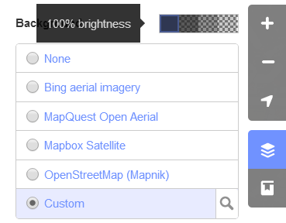

**Shortcuts:**

Note: The user can access more editing options/shortcuts by holding the shift key and clicking more than one feature. For instance, to merge two lines, the user will hold shift, select the two lines to be merged and then click the + sign. When saving, remember to insert comments. It is also necessary to leave comments when completing your tile as it informs the reviewer the status of the tile as you left it.

**Leaving Comments:** The clipped message below will appear on the left-hand side of your page. 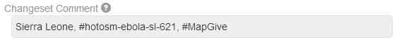

**To pan across ID Editor:**

* + (on numpad) – zoom in
* - (on numpad) – zoom out
* ↓, ↑, ←, → (cursor keys) – pan map

**To add/edit features:**

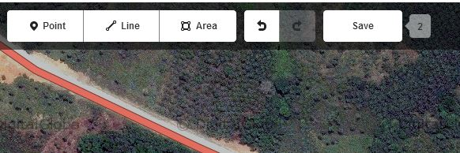

* 1 – switch to "add point" mode
* 2 – switch to "add line" (aka “way”) mode
* 3 – switch to "add area" mode
* A – continue drawing a line at the selected node
* B – display background layer switcher
* C – combine two lines (need to be connected by a shared node and be both selected before)
* D – if shared node of multiple lines is selected: unjoins the associated lines (that duplicate the shared node)
* H – show in-editor help/documentation

**Editor Wheel shortcuts (accessing the editor wheel is done by simply clicking on any feature):**

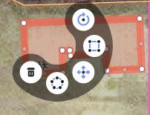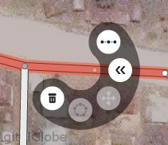

* M – move object (if object is selected)
* O – arrange nodes as circle (only closed lines, that is: areas)
* R – rotate object
* S – straighten the selected line, *or* square the corners of the selected area or closed line
* Ctrl+S – save

**Editing multiple features at the same time (ex. Splitting and joining lines):**

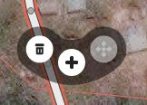

* ⇧ Shift + mouse click – selection of multiple objects
* V – reverse line direction (if line selected)
* X – split line (if node in line selected)
* Ctrl+Z – undo last action
* Ctrl+⇧ Shift+Z / Ctrl+Y (on Windows) – redo last undid action
* Ctrl+Del / Ctrl+← Backspace – delete currently selected object
* ↵ Enter / Esc – stop drawing of a line or area
* F11 (Linux, Windows) / Ctrl+⌘ Cmd+F (Mac) – set your browser to full screen mode for more space (generic browser shortcut and varies by browser)

**Tracing Examples for Common Features**

Separated Buildings

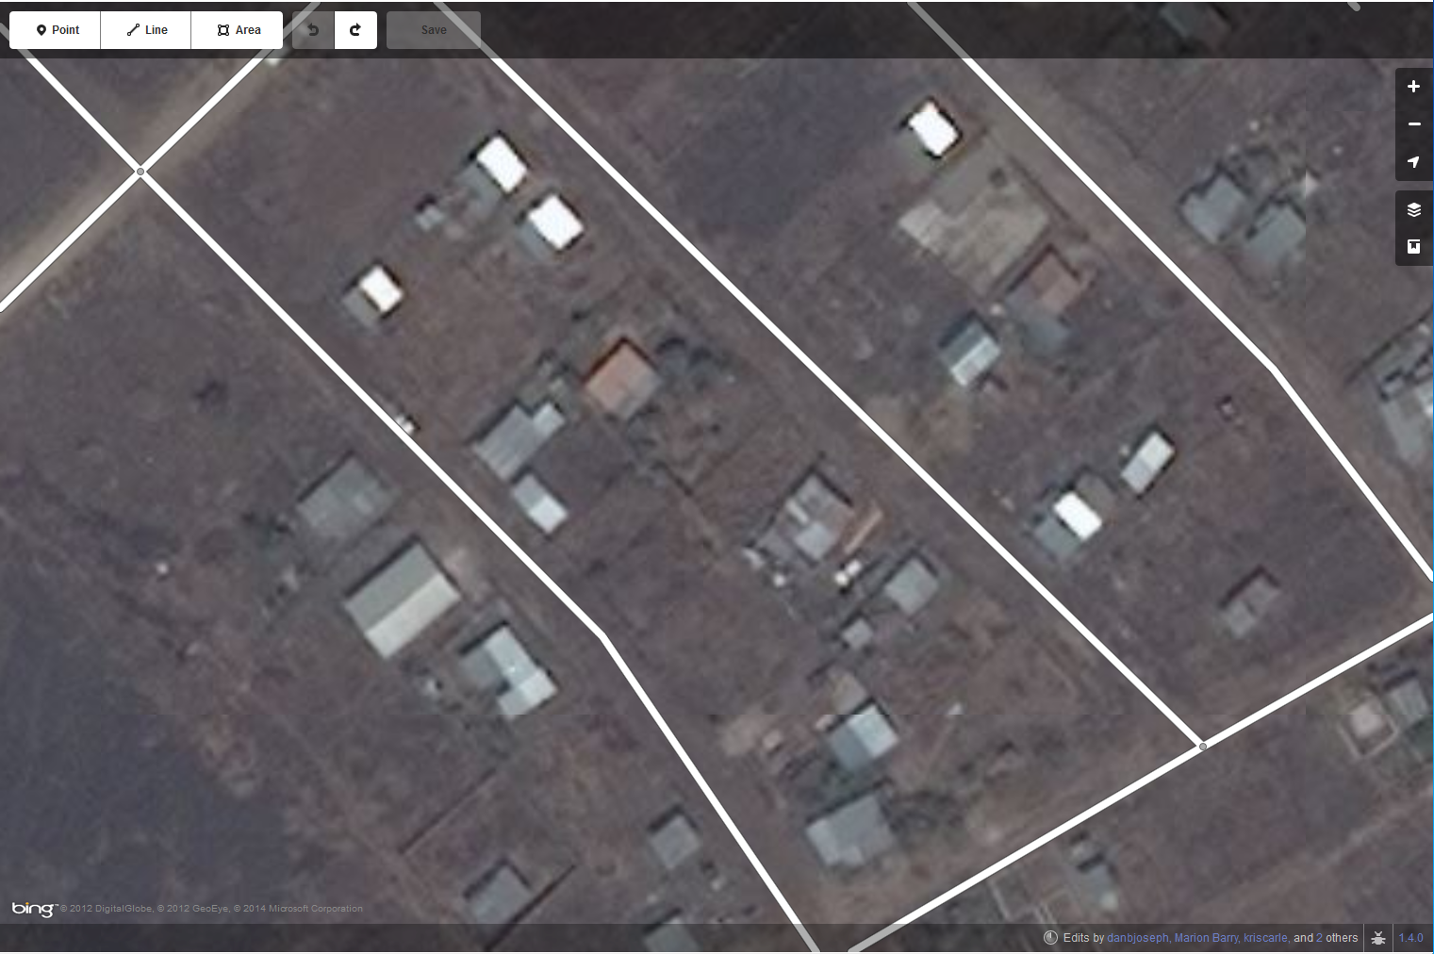

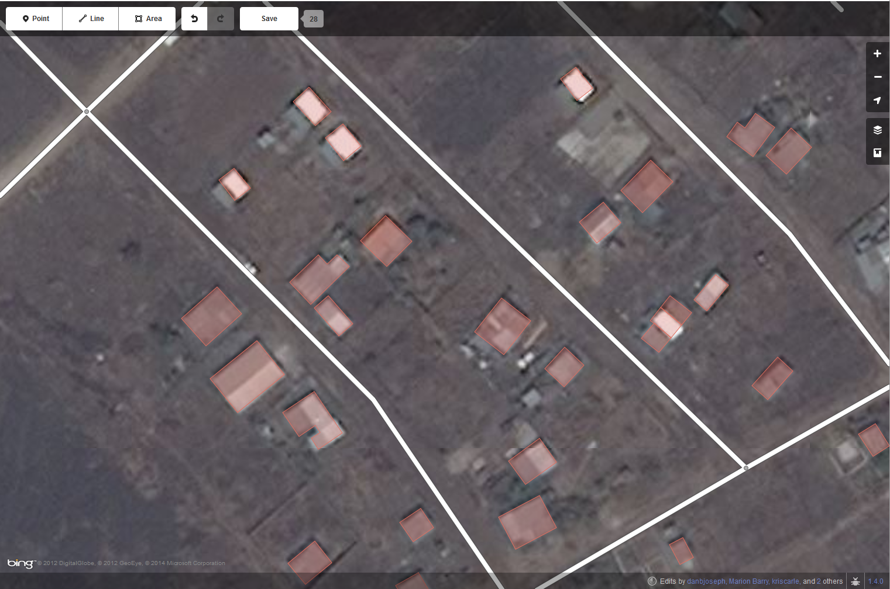

Figure 1 Above image shows before editing in buildings, below image shows after edits are made.

Adjoining Buildings

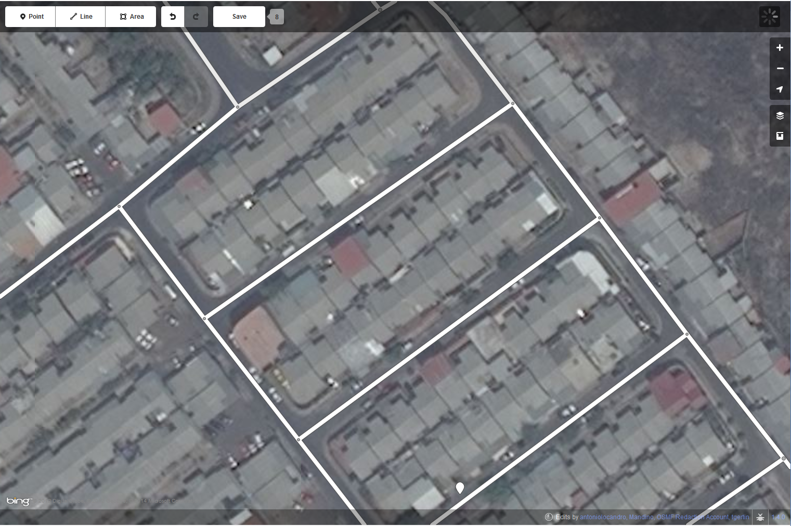

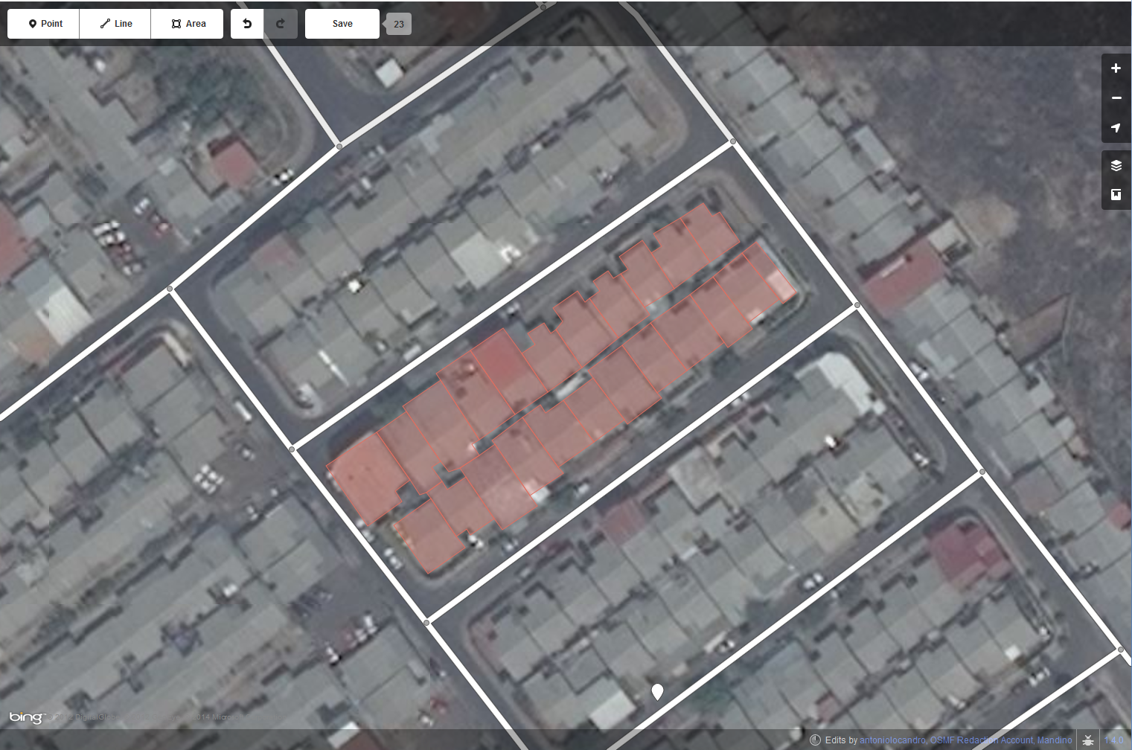

Figure 2 Above image shows before editing in buildings, below image shows after edits are made (for selected buildings).

Road Edits

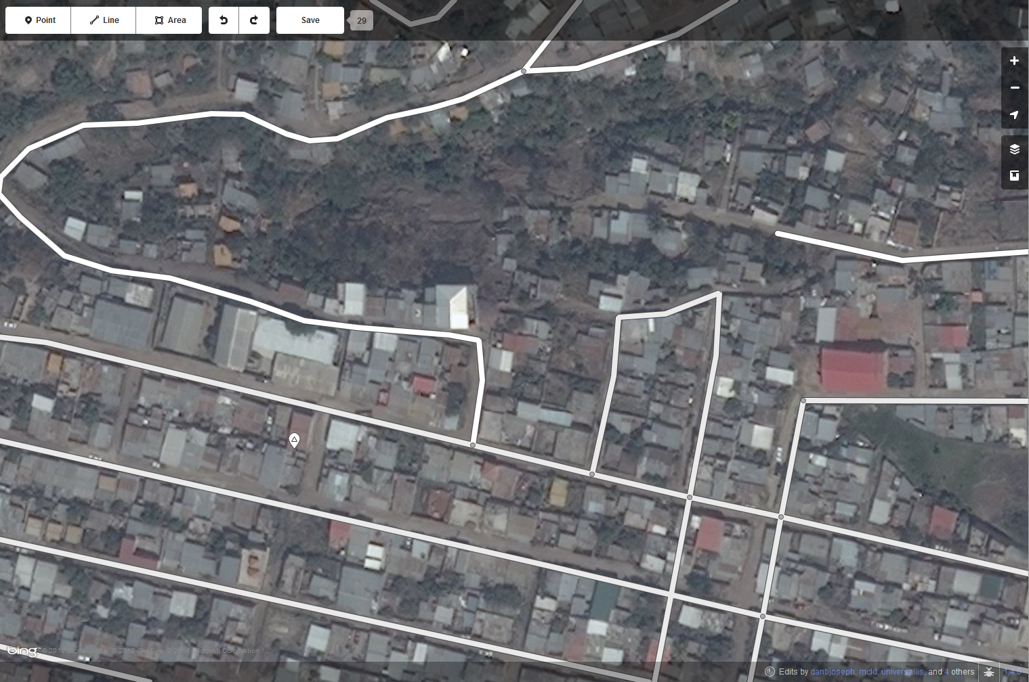

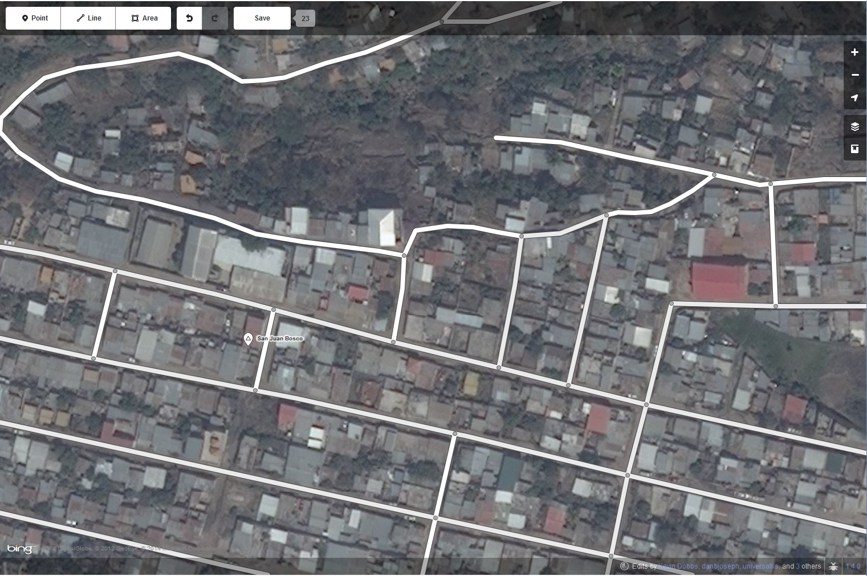

Figure Above image shows before edits are made on an area with some existing OSM data, below image shows after edits are made.

Added Deleted Moved